**Winter Carnival**

The Quebec Winter Carnival , commonly known in both English and French as Carnaval, is a [pre-Lenten festival](https://en.wikipedia.org/wiki/Lent#Pre-Lenten_observances) held in [Quebec City](https://en.wikipedia.org/wiki/Quebec_City). After being held intermittently since 1894, the Carnaval de Québec has been celebrated annually since 1955.[[1]](https://en.wikipedia.org/wiki/Quebec_Winter_Carnival#cite_note-1) That year, Bonhomme Carnaval, the mascot of the festival, made his first appearance.[[2]](https://en.wikipedia.org/wiki/Quebec_Winter_Carnival#cite_note-Shafto2009-2) Up to one million people attended the Carnaval de Québec in 2006 making it, at the time, the largest winter festival in the world (since overtaken by the [Harbin Festival](https://en.wikipedia.org/wiki/Harbin_International_Ice_and_Snow_Sculpture_Festival)).[[3]](https://en.wikipedia.org/wiki/Quebec_Winter_Carnival#cite_note-DavidsonKarr2006-3)[[4]](https://en.wikipedia.org/wiki/Quebec_Winter_Carnival#cite_note-4) It is, however, the largest winter festival in the Western Hemisphere.

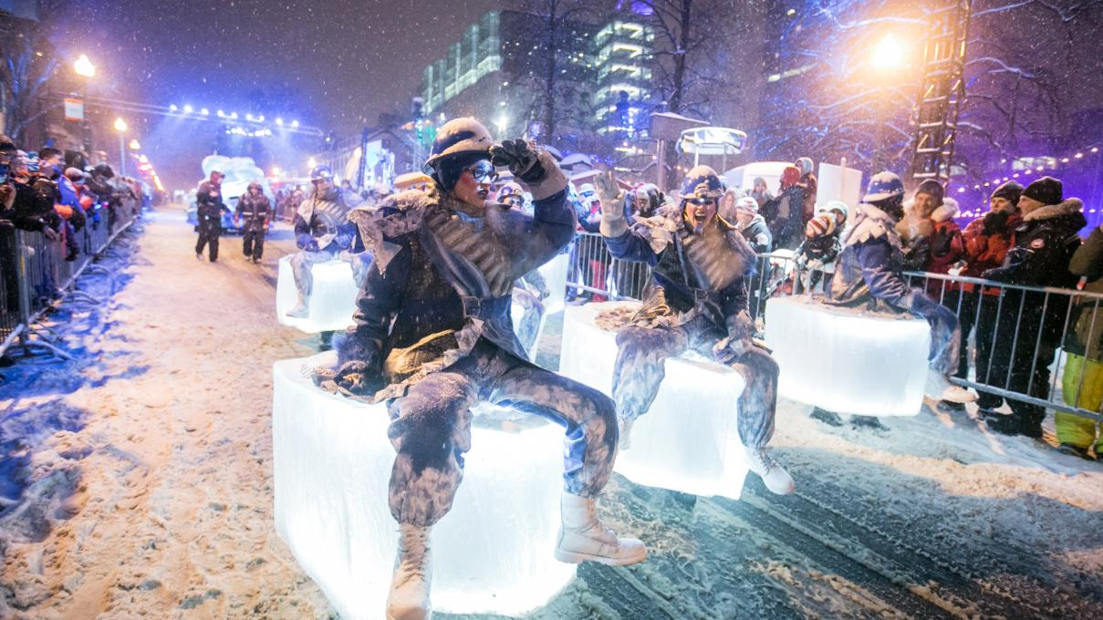

Activities and attractions

The most famous attractions of this winter festival are the night-time and daytime parades led by mascot Bonhomme Carnaval. The parades wind through the upper city, decorated for the occasion with lights and ice sculptures.

Numerous public and private parties, shows and balls are held across the city, some of them outside in the bitter cold, testimony to the Québécois' fabled [joie de vivre](https://en.wikipedia.org/wiki/Joie_de_vivre).

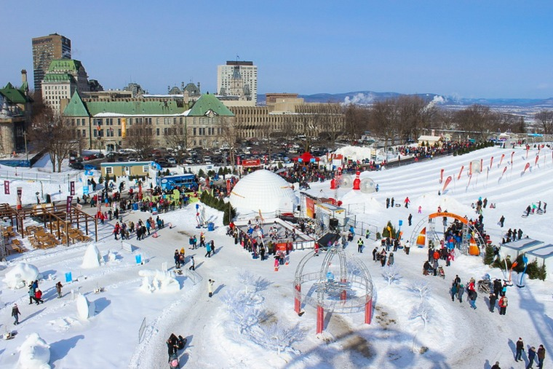

Other major events include:

* A masquerade ball with up to 400 participants at the grand ballroom of the [Château Frontenac](https://en.wikipedia.org/wiki/Ch%C3%A2teau_Frontenac).
* The opening and closing ceremonies taking place at the Ice Palace before thousands of participants, Bonhomme and the mayor of Quebec.
* Outdoor sport events (snowboarding, ice canoe, snowshoes, hockey, dog-sledding, etc., some of them part of World Championship tournaments) inside and outside the city.
* Free outdoor public banquets (brunch, breakfast, etc.).
* The Canadian, Québécois, International and Student artist snow sculpture contests on the [Plains of Abraham](https://en.wikipedia.org/wiki/Plains_of_Abraham), the main setting of the carnival. The Plains are a public city park and stay open for leisure activities, including snowshoeing and cross-country skiing trails, during carnival time. Part of the Plains around the Citadel is transformed into an outdoor winter amusement park with various family-themed activities, including the display of the three main snow-sculpting contests (Canada's provinces, Quebec's regions, International) and the traditional bikini snow bath event (bain de neige)

Outdoor dance parties are held at the Ice Palaces.

* Kiosks and other outlets in the city sell the Bonhomme effigy tag that grants admission into most of the events, although some are free outside the main site.
* Most commercial main streets are decorated and some bars and restaurants set up a winter patio in front of their establishments.
* Bonhomme – short for bonhomme de neige ("snowman") is the official ambassador of the festivities, the castle lord of the Ice Palace. Bonhomme is described as a seven-foot-tall, four-hundred pound [snowman](https://en.wikipedia.org/wiki/Snowman) sporting a red cap, black buttons and a [ceinture fléchée](https://en.wikipedia.org/wiki/Ceinture_fl%C3%A9ch%C3%A9e) that gives acknowledgement to French-Canadian and Métis style clothing.[[6]](https://en.wikipedia.org/wiki/Quebec_Winter_Carnival#cite_note-6)
* It is traditional to drink [Caribou](https://en.wikipedia.org/wiki/Caribou_(drink)), a hot alcoholic beverage, to keep warm.
* The public [auction](https://en.wikipedia.org/wiki/Auction) is a fundraising event in aid of the carnival. This auction features many goods and services donated for silent auction and live auction.